Icom R7100 Discriminator Mod
Author: kc8mzm

WARNING
You assume all risks involved with performing this modification I will not be held responsible if you destroy your scanner

The instructions below are what I used to modify my 7100
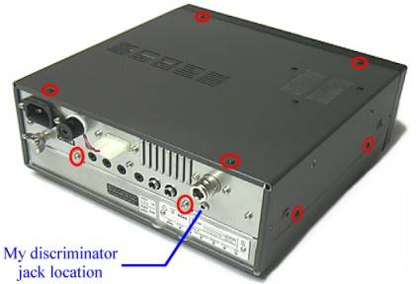
The red circles are the locations of the exterior screws that need to be removed (2 more screws on the left side are not pictured)
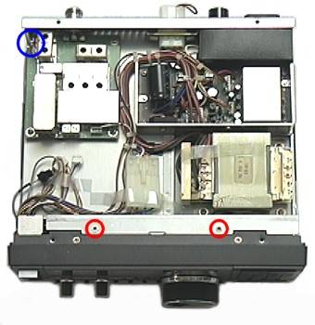
The red circles are the 2 interior screws that need to be removed The blue circle is the location of the coaxial connector (see further detail below)
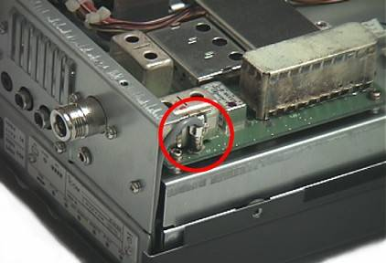
This is the small coaxial connector that needs to be unplugged
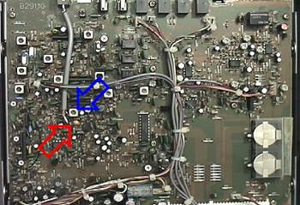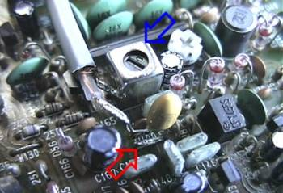
The red arrows indicate the location of wire link "W100" to which a 10u capacitor is soldered The blue arrows indicate the location of the metal can to which the shield from the audio cable is soldered
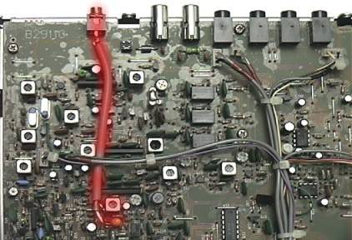
My completed discriminator tap routed to the rear of the main PC board and terminated with a 3.5mm mini phone jack
This modification can also be found on http://www.qsl.net/kc8mzm/7100.htm.

